

QTP Automation Framework

Author: PRAMOD MOORJANI

TABLE OF CONTENTS

1 The characteristics of the QTP Framework 3
2 Function Area 3
3 Functions 3
4 Function Area Script 4
5 Test Cases 4
6 The Driver Script 4
7 Directory Structure 5
8 Coding Standards 6
9 Testing of the Scripts 6

The characteristics of the QTP Framework

- Modular in design
- Enables the development of test cases using a set of reusable functions
- Provides the ability to execute dozens of test cases from a single master script
- Has Error and Exception Handling capabilities
- Is easily Scalable
- Is easily Maintainable
- Has the additional ability to report the results – function wise(with details) – to an xml file
- Desktop Screen Capture on Error – makes it easy to understand the cause of the failures

Function Area
Function 1
Function 2
Function 3
Spread Sheet 2
(Data)
Spread Sheet 3
Spread Sheet 1
Object
Repository

Function Area

The Application under test is divided into a number of Broad Areas known as Function Areas.

Functions

Each Function Area is further divided into Functions

Function Area Script

One VB script caters to One Function Area.

Each Function Area has its own Object Repository (common to all the functions in the function area)

VB Script
Function Area 1 | Function 1 | Module 2 | Module 3 | Module 4
Plan | Create Plan | Edit Plan | Delete Plan

Each Function has its own data spreadsheet

Test Cases

These Functions are combined to form test cases

Test Case Name | Function 1 | Function 2 | Function 3
TC1 | Login;1;0 | CreatePlan;4;1 | Logout;0;0
TC2 | … | …. | …..

CreatePlan;4;1 denotes a call to the

- The “Create Plan” function from the “Plan” script
- 4 denotes that while executing this Create Plan function, data should be picked up from the 4th row of this Functions’s Data Table (Spreadsheet)
- 1 denotes that this test case is an Error Message Verification Test Case
- (the possible values are 0 and 1)

The Driver Script

The Driver is the QTP script that triggers and handles the entire execution of the test cases.

The Driver script contains the following main components:

- Test Set Executer
- Execute Test Cases

Driver Notes

The Test Set Executer starts reading the Test Cases Set
It starts reading each Test Case in its Data Spreadsheet (The list of Test Cases)
After reading a Test Case, it passes control to the “Execute Test Cases” component.

The Execute Test Cases component starts reading the functions within a test case and starts calling/invoking them one after another.

Each function returns Pass/Fail on execution.

In case an error is encountered and a function fails, the test case is aborted.

When the expected page/screen/object is not found on the screen, the control is passed to the Exception Handler

The Exception Handler checks to see if the test case is for Error Message Verification
If so it checks the error message and returns Pass/Fail to the Module
Else
It captures the Error Message and returns Fail to the module

At the end of every test case the results are appended to an xml file by calling certain functions contained in the library of Common functions.

As and when a function fails, a screen shot of the Desktop is taken and a link to the same is appended to the xml result.

Directory Structure

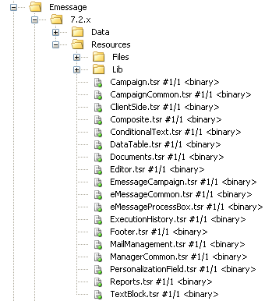

- The Lib folder contains all the VB script files (one for each function area)
- The Resources folder contains all the Object Repositories (one for each function area)
- The Data folder contains all the data spreadsheets(One for each function)

Coding Standards

- s for String variables
- i for Number variables and
- f for function name
- sb for SUB

There should be absolutely NOTHING hard coded

The Absolute Paths must come from an excel spreadsheet, ini file, an xml file or
from the Environment Variables

Testing of the Scripts
Testing of individual functions after integrating them with the Framework

Each function needs to be verified for displaying the correct results for the following conditions
- Valid Data – Business Process - Pass
- Invalid Data – Business Process - Fail

- Invalid Data – Err Msg - Expected Error Msg - Pass
- Invalid Data – Err Msg – Not the Expected Error Msg – Fail

